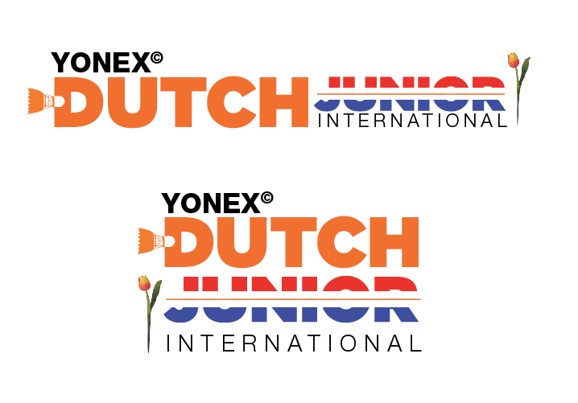

##### YONEX DUTCH JUNIOR INTERNATIONAL 2022 - GRADE A TOURNAMENT ACCOMMODATION FORM

**Bookings must be done before January 26th 2022. After this date reservations are possible on request, but depending on availability.**

To: **Yonex Dutch Junior International Tournament Committee**

c/o Mr. Jeroen Kuipers Phone: +31624368078

Badmintonhall DEGIRO-hal

Badmintonplein 1

2023 BW Haarlem

The Netherlands Email: reservations@dutchjunior.com

**Contact information:**

|  |  |
| --- | --- |
| National Association of: |  |
| Contact person: |  |
| Phone number: |  |
| Email: |  |

**Invoicing information**

|  |  |
| --- | --- |
| Name: |  |
| Contact: |  |
| Address: |  |
| Postal code: |  |
| City: |  |
| Country: |  |

Yonex Dutch Junior International gives you the possibility to book your stay at **Hotel Ibis Styles, The Niu Dairy** or **Youth Hostel Stayokay**. Making a hotel reservation via Yonex Dutch Junior International also provides you **transport** to and from the airport, pick-up from the hotel, the training facilities and tournament hall during the event. The Tournament Committee has options on the following accommodations. All prices in Euros for Bed & Breakfast. PLEASE NOTE: Tourist Tax is excluded.

Payment is to be done directly to the hotel via Credit card authorisation (Hotel Ibis Styles and The Niu Dairy). Payment for the Youth Hostel is done directly to the tournament organisation.

**HOTEL RATES**

|  |  |  |  |  |  |
| --- | --- | --- | --- | --- | --- |
| Hotel | **Distance to Hall** | **Single use** | **Double use** | **Triple use** | **p.p.p. night** |
| Hotel Ibis Styles | 0,4 km | € 100,00 | € 117,50 | € 145,00 | - |
| The Niu Dairy | 2,6 km | € 85,00 | € 97,50 | - | - |
| Youth Hostel Stayokay | 2,7 km | - | - | - | € 37,50 |

**OUR ASSOCIATION MAKES THE FOLLOWING RESERVATION:**

|  |  |  |  |  |  |
| --- | --- | --- | --- | --- | --- |
| Hotel | **Single use** | **Double use** | **Triple use** | **Arrival**  **date** | **Departure date** |
| Hotel Ibis Styles |  |  |  |  |  |

Please fill in: number of rooms, arrival and departure date.

|  |  |  |  |  |
| --- | --- | --- | --- | --- |
| Hotel | **Single use** | **Double use** | **Arrival date** | **Departure date** |
| The Niu Dairy |  |  |  |  |

Please fill in: number of rooms, arrival and departure date.

|  |  |  |  |  |  |  |
| --- | --- | --- | --- | --- | --- | --- |
| **Hotel** | **Number of female players** | **Number of male players** | **Number of female coaches** | **Number of male coaches** | **Arrival date** | **Departure date** |
| Youth Hostel Stayokay |  |  |  |  |  |  |

Please fill in: number of players/coaches, arrival and departure date.

Date: ….-….-....

Signature: ………………………..

Please return your booking form to [reservations@dutchjunior.com](mailto:reservations@dutchjunior.com)

**CANCELLATION POLICY**

1. In case of Cancellation more than 3 months before the Commencement Date, the Customer is not obliged to make any payment to the Hotel Establishment.
2. In case of Cancellation more than 2 months before the Commencement Date, the Customer is obliged to pay 15% of the Reservation Value to the Hotel Establishment
3. In case of Cancellation more than 1 month before the Commencement Date, the Customer is obliged to pay 35% of the Reservation Value to the Hotel Establishment
4. In case of Cancellation more than 14 days before the Commencement Date, the Customer is obliged to pay 60% of the Reservation Value to the Hotel Establishment
5. In case of Cancellation more than 7 days before the Commencement Date, the Customer is obliged to pay 85% of the Reservation Value to the Hotel Establishment.
6. In case of Cancellation 7 days or less before the Commencement Date, the Customer is obliged to pay 100% of the Reservation Value to the Hotel Establishment.